Lesotho

## Population Data

The data set shows the political stability estimate of the country each year.

## # A tibble: 23 x 5  
## country iso3c date population popCategory5  
## <chr> <chr> <dbl> <dbl> <chr>   
## 1 Lesotho LSO 1996 1934291 very small   
## 2 Lesotho LSO 1997 1968044 very small   
## 3 Lesotho LSO 1998 1997516 very small   
## 4 Lesotho LSO 1999 2019731 very small   
## 5 Lesotho LSO 2000 2032804 very small   
## 6 Lesotho LSO 2001 2035740 very small   
## 7 Lesotho LSO 2002 2029829 very small   
## 8 Lesotho LSO 2003 2018348 very small   
## 9 Lesotho LSO 2004 2005940 very small   
## 10 Lesotho LSO 2005 1996114 very small   
## 11 Lesotho LSO 2006 1989939 very small   
## 12 Lesotho LSO 2007 1986922 very small   
## 13 Lesotho LSO 2008 1987129 very small   
## 14 Lesotho LSO 2009 1990131 very small   
## 15 Lesotho LSO 2010 1995581 very small   
## 16 Lesotho LSO 2011 2003787 very small   
## 17 Lesotho LSO 2012 2014990 very small   
## 18 Lesotho LSO 2013 2028519 very small   
## 19 Lesotho LSO 2014 2043437 very small   
## 20 Lesotho LSO 2015 2059021 very small   
## 21 Lesotho LSO 2016 2075001 very small   
## 22 Lesotho LSO 2017 2091412 very small   
## 23 Lesotho LSO 2018 2108132 very small

# Population growth data

## # A tibble: 23 x 5  
## country iso3c date popGrowth popGrowthCat5   
## <chr> <chr> <dbl> <dbl> <chr>   
## 1 Lesotho LSO 1996 1.86 moderate growth rate  
## 2 Lesotho LSO 1997 1.73 moderate growth rate  
## 3 Lesotho LSO 1998 1.49 slow growth rate   
## 4 Lesotho LSO 1999 1.11 slow growth rate   
## 5 Lesotho LSO 2000 0.645 slow growth rate   
## 6 Lesotho LSO 2001 0.144 slow growth rate   
## 7 Lesotho LSO 2002 -0.291 declining   
## 8 Lesotho LSO 2003 -0.567 declining   
## 9 Lesotho LSO 2004 -0.617 declining   
## 10 Lesotho LSO 2005 -0.491 declining   
## 11 Lesotho LSO 2006 -0.310 declining   
## 12 Lesotho LSO 2007 -0.152 declining   
## 13 Lesotho LSO 2008 0.0104 slow growth rate   
## 14 Lesotho LSO 2009 0.151 slow growth rate   
## 15 Lesotho LSO 2010 0.273 slow growth rate   
## 16 Lesotho LSO 2011 0.410 slow growth rate   
## 17 Lesotho LSO 2012 0.558 slow growth rate   
## 18 Lesotho LSO 2013 0.669 slow growth rate   
## 19 Lesotho LSO 2014 0.733 slow growth rate   
## 20 Lesotho LSO 2015 0.760 slow growth rate   
## 21 Lesotho LSO 2016 0.773 slow growth rate   
## 22 Lesotho LSO 2017 0.788 slow growth rate   
## 23 Lesotho LSO 2018 0.796 slow growth rate

## Population trend

The plot shows the population trend of the country.

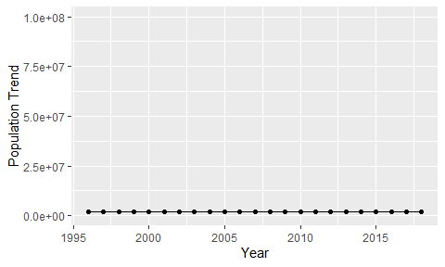

Political Stability Trend

# Population growth trend

The plot shows the population growth rate trend of the country.

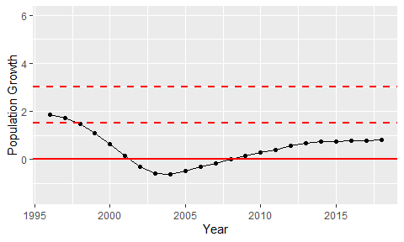

Population Growth Trend